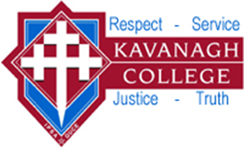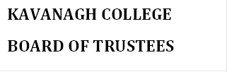

POLICY: CURRICULUM DELIVERY

Rationale:

Kavanagh College is committed to deliver a balanced curriculum where excellence is the focus, co-operatively designed and responsive to the needs of individual learners within a framework consistent with National Education Guidelines, and the special character and the strategic plan of the College.

Guidelines:

- Kavanagh College will provide all pupils with the opportunity to acquire knowledge, understanding and an appreciation of faith and religion through a compulsory Religious Education programme from years 7-13.
- The special character of the College will be expressed through both subject content and classroom practices.
- An understanding of the implications of the Treaty of Waitangi across the curriculum will be fostered.
- The College will develop appropriate programmes for all students, including those with special needs.
- Each department will have a plan for delivery of the curriculum within that department. This plan will be used to guide teachers in their planning and assessment.
- The school will operate a careers and transition programme.
- Students from year 9 will be exposed to a range of option subject choices in addition to the core curriculum.
- An appropriate Outdoor Education programme will be provided. There will be opportunities for students to develop appropriate thinking, studying and social skills as an integral part of the curriculum.
- The College will implement technology through specialist programmes as well as integrated throughout the curriculum.
- The Curriculum & Assessment Committee will co-ordinate future curriculum developments and reviews in the College.

