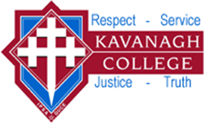

POLICY: PARENTS AND CAREGIVERS AND COMMUNITY PARTNERSHIP

Rationale:
The creation and maintenance of a good partnership with the College's community is essential for the successful implementation of the Charter. Such a relationship requires an open and welcoming atmosphere that acknowledges the importance of parental/caregiver support and seeks input from all members of the College's community.

Purpose:
- To ensure a high level of community partnership in order to enhance the learning of all pupils at the College.
- To support appropriate fundraising endeavours, which will provide facilities at the College for the use and enjoyment of the College's pupils, staff and community
- To promote the College and its aims to the wider community.

Guidelines:
- The College will use a variety of media to inform the community of its activities. These will include a weekly newsletter, the school website, a calendar of events, parish bulletins and the Diocesan News, as well as local newspapers.
- The Board will widely circulate the time and place of meetings and invite attendance at the meetings and will have minutes available at school offices.
- The Board will consider the views of the community in policy matters via a biennial survey.
- The College will promote good contact with parents through regular communication and written invitations to meet teachers.
- Parents will be encouraged to participate in College affairs through the Parent and Friends Association, attendance at class liturgies and school assemblies, College and Board events, including College extracurricular activities.
- Tutor teachers, Deans and the Pastoral Team are expected and encouraged to maintain close communications and dialogue with parents/caregivers over student concerns relating to academic progress or behaviour/discipline.
- The Board supports the use of College facilities wherever the community can use them safely and without cost to the school and within the framework of our Special Character.
- The College will encourage interaction with the College Alumni Association.

