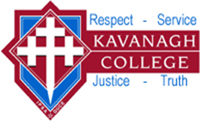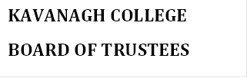

POLICY: TREATY OF WAITANGI

Rationale:

We recognise that Kavanagh College has an obligation and a desire to give effect to the intention of the Treaty of Waitangi so that we may grow as equals.

In the interests of Social Justice, Kavanagh College should be responsive to the needs and aspirations of all members of our community.

Purpose:

Our Special Character guides us to be sensitive to the legitimate needs and
aspirations of all members of our school community, especially Tangata Whenua.

Our education will encourage an understanding of both the requirements of partnership and the dual heritage of our country.

Guidelines:

1. Provide opportunities for all students wishing to learn Maori having regard to resources and staffing.
2. Works towards incorporating Tikanga Maori* in all subjects and extra-curricular activities, and reviews these as part of the College plan for Curriculum review.
4. Encourage the Maori Community to participate in College life and decisions so
that the partnership is recognised and embedded in practice.
5. Provide in-service opportunities for staff to gain experience and skills in teaching Te Reo and supporting Treaty values, issues and implications.
6. When appointing to teaching positions relating to Maori Language the Whanau will be consulted and the process will reflect Maori Values and procedures.

*All language, culture and values.

